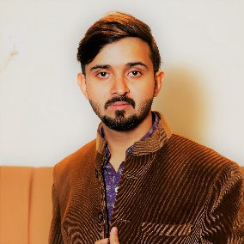**MUEID ALI KHAN**

Contact no: 03152188745

Email: **mueidali1234@gmail.com**

**Objective:**

Seeking challenging environment that encourages continuous learning and creativity providing exposure to new ideas and stimulate personal and professional growth.

**Education:**

* **MASTERS (M.Sc) 2019**
* *ENTOMOLOGY:*

UNIVERSITY OF KARACHI

* **BACHELORS (B.Sc) 2018**
* *ZOOLOGY***:**

UNIVERSITY OF KARACHI

* **INTERMEDIATE (HSC) 2015**
* *PRE-MEDICAL:*

B.I.E.K

* **MATRICULATION (SSC) 2013**
* *BIOLOGY:*

B.S.E.K

**Course:**

* *CERTIFICATE IN I.T (C.I.T)*

V.T.C

* *ARTIFICIAL INTELLIGENCE (A.I)*

P.I.A.I.C

* *AI FOR EVERYONE* (COURSERA)

**Extracurricular activities:**

* **Workshops:**
* *ECOTOXICOLOGY* (PCSIR)
* *CLIMATE CHANGE AND ECOSYSTEM* (IUCN)
* *ADVANCED EXCEL (SPECIALZED PROGRAM)*

SYMPDC, U.O.K

**Skills and Strength:**

* **Interpersonal:**

Adaptable, friendly energetic, innovative and leading personality. Enjoy challenges, ambitious and ability to work under pressure for achieving goals. Flexible and love to work in team.

* **Computer:**

Highly efficient and well working command and knowledge of MS OFFICE, PYTHON Programming, Windows and internet

* **Language:**

Urdu**,** English

**Personal Information;**

Father Name: Musharaf Ali Khan

Date of Birth: November 2nd, 1995

Nationality: Pakistani

Marital Status: Single

Address: House# E-408, 2nd FLOOR, khudadad colony, karachi